Nama : Kayla Puteri Gunawan
NIM : 211331010
Kelas : 1A – TTE
Soal BAB 4 (buku electronic devices and circuit theory, R boylestad ) 1 – 32
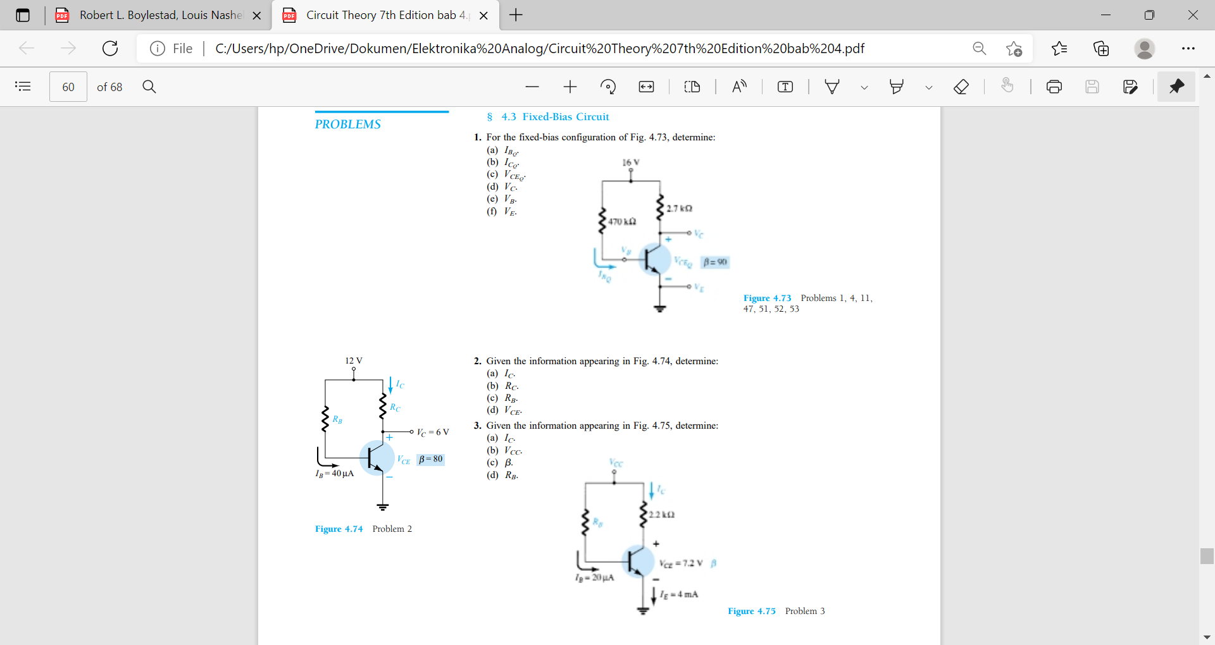
- For he fixed-bias configuration of Fig. 4.73, determine:
a. IBQ
b. ICQ
c. VCEQ
d. VC
e. VB
f. VE
Jawab :
- IBQ = $\frac{Vcc - VBE}{RB}$ = = $\frac{16 V- 0,7 V}{510 kΩ}$ = $\frac{15,3 V}{510 kΩ}$ = 30 μA
- ICQ = $βI$BQ = (120)(30 μA) = 3,6 mA
- VCEQ = Vcc – ICQ Rc = 16 V − (3,6 mA)(1,8 kΩ) = 9,52 V
- VC = VCEQ = 6,48 V
- VB = VBE = 0,7 V
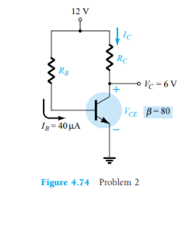
- VE = 0 V
- Given the information appearing in Fig. 4.74, determine:
a. IC
b. Rc
c. RB
d. VCE
Jawab :
- IC = $βI$B = 80(40 μA) = 3,2 mA
- Rc = $\frac{VRC}{Ic}$ = = $\frac{Vcc - Vc}{Ic}$ = $\frac{12 V-6 V}{3,2 mA}$ = $\frac{6 V}{3,2 mA}$ = 1.875 kΩ
- RB = $\frac{VRB}{IB}$ = $\frac{12 V- 0,7 V}{40 A}$ = $\frac{11,3 V}{40 A}$ = 282.5 kΩ
- VCE = VCE = 6 V
- Given the information appearing in Fig. 4.75, determine:
a. IC
b. Vcc
c. $β$
d. RB
Jawab :
- IC = IE − IB = 4 mA − 20 μA = 3.98 mA ≅ 4 mA
- VCC = VCE + ICRC = 7,2 V + (3,98 mA)(2,2 kΩ)
= 15.96 V ≅ 16 V
- $β$ = $\frac{IC}{IB}$ = $\frac{3,98 mA}{20 A}$ = 199 ≅ 200
- RB = $\frac{VRB}{IB}$ = $\frac{Vcc-VBE}{IB}$ = $\frac{15,96 V-0,7 V }{20 A}$ = 763 kΩ
- Find the saturation current (ICsat) for the fixed-bias configuration of Fig. 4.73.
Jawab : ICsat = $\frac{Vcc}{RC}$ = $\frac{16 V }{2,7 k}$ = 5.93 mA
- Given the BJT transistor characteristics of Fig. 4.76:
a. Draw a load line on the characteristics determined by E = 21 V

and RC = 3 k for a fixed-bias configuration.
b. Choose an operating point midway between cutoff and saturation. Determine

the value of RB to establish the resulting operating point.
c. What are the resulting values of ICQ and VCEQ?
d. What is the value of $β$ at the operating point?
e. What is the value of $α$ defined by the operating point?
F. What is the saturation (ICsat) current for the design?
G. Sketch the resulting fixed-bias configuration.
H. What is the dc power dissipated by the device at the operating point?
I. What is the power supplied by VCC?
J. Determine the power dissipated by the resistive elements by taking the difference between the results of parts (h) and (i).

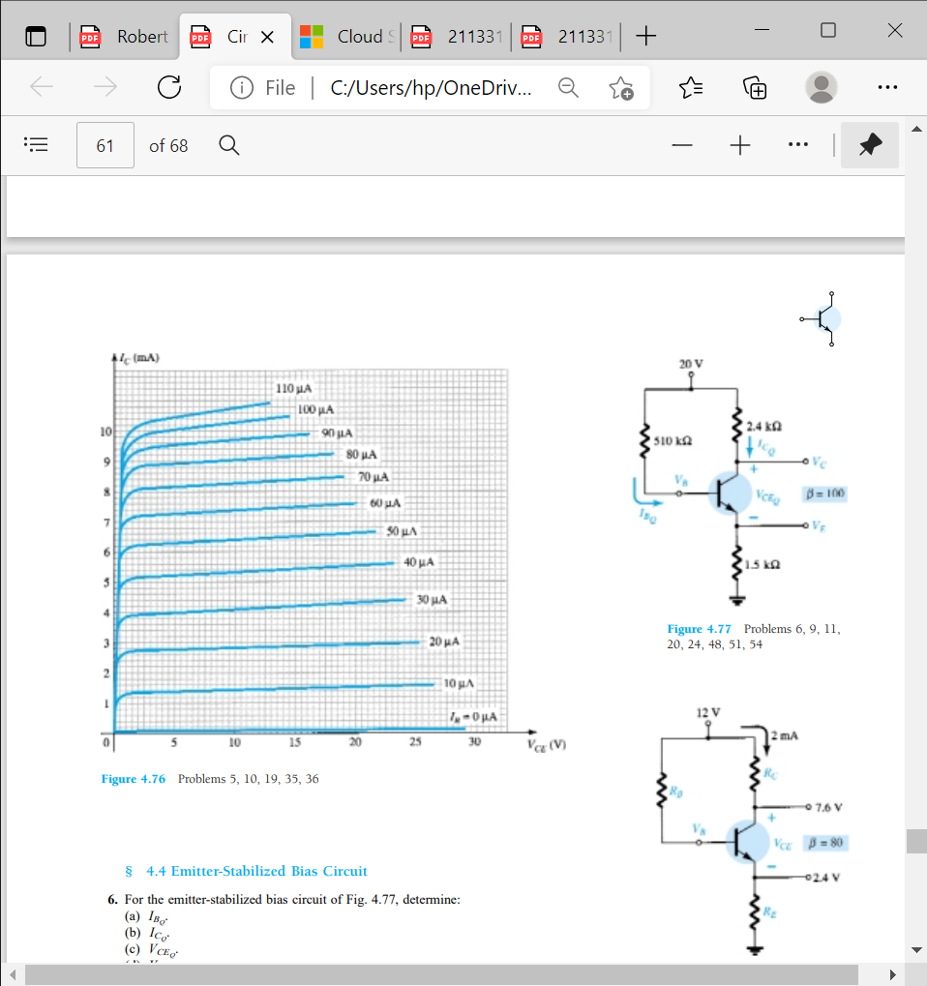
Jawab :
- Load line intersects vertical axis at IC = $\frac{21 V}{3 k }$ = 7 mA and horizontal axis at VCE = 21 V.
- IB = 25 μA: RB = $\frac{Vcc-VBE}{IB }$ = = $\frac{21 V-0,7 V }{25 A}$ = 812 kΩ
- ICQ ≅ 3,4 mA, VCEQ ≅ 10,75 V
- $β$ = $\frac{IC}{IB}$ = $\frac{3,4 mA}{25 A}$ = 136
- $α$ = $\frac{β}{β+1}$ = $\frac{136}{136+1 }$ = $\frac{136}{137 }$ = 0,992
- ICsat = $\frac{Vcc}{RC}$ = $\frac{21 V }{3 k}$ = 7 mA
- –
- PD = VCEQ . ICQ = (10,75 V)(3,4 mA) = 36,55 mW
- Ps = Vcc (Ic + IB) = 21 V(3,4 mA + 25 μA) = 71,92 mW
- PR = Ps − PD = 71,92 mW − 36,55 mW = 35,37 mW
- For the emitter-stabilized bias circuit of Fig. 4.77, determine:
a. IBQ
b. ICQ
c. VCEQ
d. Vc
e. VB
f. VE
Jawab :
- IBQ = $\frac{Vcc-VBE }{RB+\left(β+1\right)RE}$ = $\frac{20 V-0,7 }{510 k +\left(101\right)1,5 k}$

=$\frac{19,3 V}{661,5 k}$ = 29,18 μA
- ICQ = βIBQ = (100)(29,18 μA) = 2,92 mA
- VCEQ = VCC − IC(RC + RE) = 20 V − (2,92 mA)(2,4 kΩ + 1,5 kΩ)
= 20 V – 11,388 V
= 8,61 V
- VC = VCC – IC.RC = 20 V − (2,92 mA)(2,4 kΩ) = 20 V – 7,008 V = 13 V
- VB = VCC – IB.RB = 20 V − (29,18 μA)(510 kΩ)
= 20 V – 14,882 V = 5,12 V
- VE = VC − VCE = 13 V – 8,61 V = 4,39 V

